Shrinkage correlation: USDCAD and EURGBP
Method 08 / eight-major panel / delta = 0.2 and Ledoit-Wolf / Alpari D1 full available history

Study setup
Logical pair: USDCAD , EURGBP
Broker symbols: USDCAD_i , EURGBP_i
Snapshot: 2026-11-03_majors_alpari_D1
Timeframe: D1
Common eight-major panel window: 1999-01-06 to 2026-11-02 (UTC bar dates)
Panel matched return count n: 7127
Dropped unfinished last bar dated 2026-11-03 UTC after a tick-volume check against the prior complete day.
Fixed shrinkage: delta=0.2, mu=3.9170889e-05 (mean of diag(S))
Ledoit-Wolf estimated delta: 0.0042157642
Panel symbols: EURUSD, GBPUSD, AUDUSD, NZDUSD, USDJPY, USDCHF, USDCAD, EURGBP
Complete matched rows (Excel): USDCAD-EURGBP_Shrinkage_D1.xlsx
Complete matched rows (HTML table): USDCAD-EURGBP_Shrinkage_D1_data.html

Method carried forward
Shrinkage blends the sample covariance matrix S of matched daily log returns of close, ln(close_t / close_t-1), toward a simple target, then converts the shrunk covariance into correlations. Quotes are not inverted. This experiment builds one common calendar across all eight majors, forms S with the unbiased n-1 divisor, then reports two shrinkage specs: fixed delta = 0.2 with mu equal to the average sample variance (mu * I target), and sklearn Ledoit-Wolf with its estimated delta. Pair reports pull rho_ij from those panel matrices. Same-panel Pearson r is a side check only. Shrinkage improves conditioning; it is not a cause, not a lead, and not a trading signal.

Results
pearson_r | rho_02 | rho_LW | rho_02_minus_r | rho_LW_minus_r | delta_LW
-0.014713 | -0.010579 | -0.014616 | 0.004134 | 9.7e-05 | 0.00421576

Conclusion
Over the common 7127-day eight-major panel for USDCAD and EURGBP (broker quote directions unchanged), fixed-delta shrinkage correlation at delta=0.2 is -0.0106 (negative, weak linear link in this sample). Ledoit-Wolf rho is -0.0146 with estimated delta=0.004216. Same-panel Pearson r is -0.0147 (rho_02 minus r = 0.0041; rho_LW minus r = 0.0001). This does not establish cause, lead-lag, or a lasting trading rule.

Charts
Daily closes
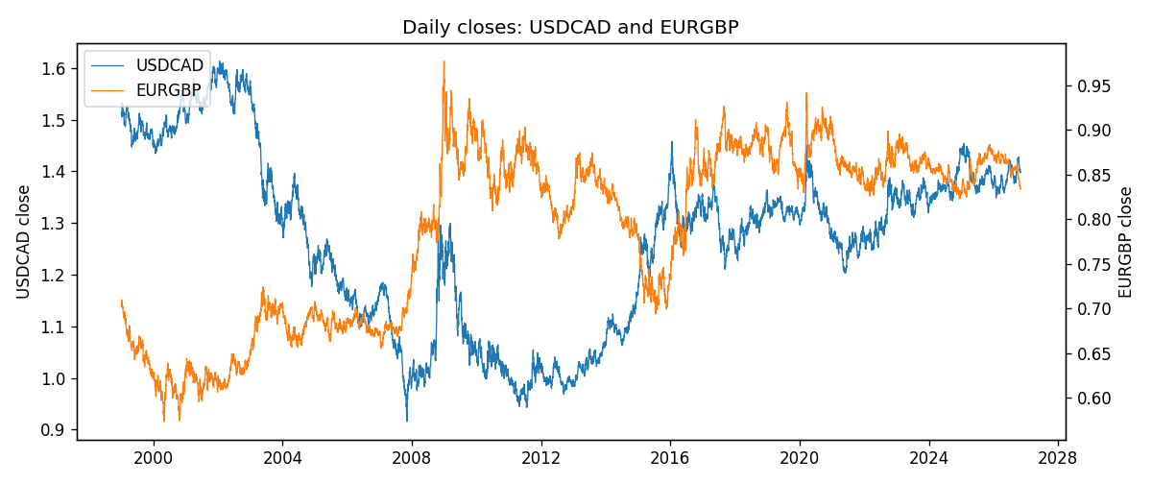
Daily log returns
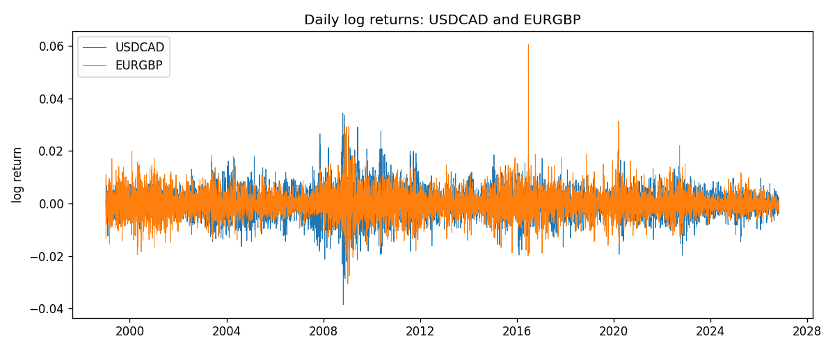
Log-return scatter
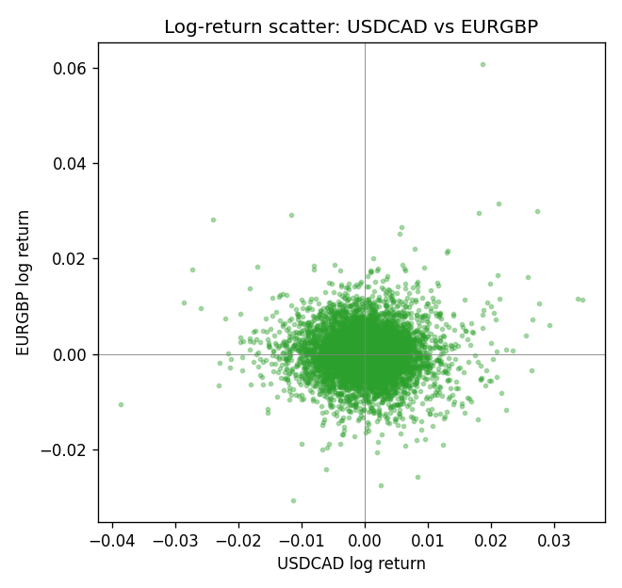

Data report
Every panel row for this pair slice is stored in the sibling Excel workbook named USDCAD-EURGBP_Shrinkage_D1.xlsx. Full-panel covariance and correlation matrices are saved once under outputs/ as CSV files. Embedding all rows as a Word table is impractical at this length; the Word file holds the column list, column summaries, and the first and last 15 matched rows.
Columns: time, USDCAD_open, USDCAD_high, USDCAD_low, USDCAD_close, USDCAD_tick_volume, USDCAD_spread, USDCAD_real_volume, USDCAD_log_return, EURGBP_open, EURGBP_high, EURGBP_low, EURGBP_close, EURGBP_tick_volume, EURGBP_spread, EURGBP_real_volume, EURGBP_log_return
Column summaries (panel rows)
column | count | mean | std | min | 25% | 50% | 75% | max
USDCAD_open | 7127 | 1.2660158 | 0.16869092 | 0.9168 | 1.11698 | 1.29814 | 1.371685 | 1.6183
USDCAD_high | 7127 | 1.2709144 | 0.16864061 | 0.9336 | 1.122275 | 1.30368 | 1.37575 | 1.619
USDCAD_low | 7127 | 1.2614634 | 0.1687284 | 0.9056 | 1.112315 | 1.29315 | 1.36729 | 1.6102
USDCAD_close | 7127 | 1.2660395 | 0.16866578 | 0.916 | 1.116855 | 1.298 | 1.371955 | 1.6137
USDCAD_tick_volume | 7127 | 81672.889 | 147760.33 | 56 | 5669.5 | 41299 | 71973 | 1410818
USDCAD_spread | 7127 | 23.249895 | 18.19595 | 0 | 9 | 17 | 40 | 60
USDCAD_real_volume | 7127 | 1.8530805e+10 | 9.7086285e+10 | 0 | 0 | 0 | 0 | 2.5751613e+12
USDCAD_log_return | 7127 | -7.67e-06 | 0.00514753 | -0.03859748 | -0.0028338 | 5.597e-05 | 0.00272861 | 0.03436319
EURGBP_open | 7127 | 0.78791082 | 0.09637243 | 0.5734 | 0.6884 | 0.83449 | 0.8655 | 0.9769
EURGBP_high | 7127 | 0.79099288 | 0.09674788 | 0.5789 | 0.6906 | 0.83742 | 0.868415 | 0.9799
EURGBP_low | 7127 | 0.78520819 | 0.09619038 | 0.5682 | 0.6864 | 0.83222 | 0.86303 | 0.9661
EURGBP_close | 7127 | 0.7879552 | 0.09637142 | 0.5735 | 0.6884 | 0.83458 | 0.86556 | 0.977
EURGBP_tick_volume | 7127 | 87771.585 | 145890.89 | 332 | 6734 | 44866 | 82002 | 1424684
EURGBP_spread | 7127 | 21.129928 | 19.050945 | 0 | 4 | 13 | 40 | 50
EURGBP_real_volume | 7127 | 2.8086114e+10 | 1.3572254e+11 | 0 | 0 | 0 | 0 | 3.5726265e+12
EURGBP_log_return | 7127 | 2.379e-05 | 0.00487339 | -0.03067367 | -0.00262314 | -9.978e-05 | 0.00256668 | 0.06075387
First 15 panel rows (selected columns)
time | USDCAD_close | EURGBP_close | USDCAD_log_return | EURGBP_log_return
1999-01-06 | 1.5118 | 0.7019 | -0.0003306769 | -0.013303338
1999-01-07 | 1.5141 | 0.7097 | 0.0015202092 | 0.011051402
1999-01-08 | 1.511 | 0.7062 | -0.0020495197 | -0.004943862
1999-01-11 | 1.5057 | 0.7053 | -0.0035137769 | -0.0012752393
1999-01-12 | 1.5157 | 0.7077 | 0.0066194721 | 0.0033970309
1999-01-13 | 1.5226 | 0.708 | 0.0045420214 | 0.00042381861
1999-01-14 | 1.5332 | 0.7066 | 0.0069376546 | -0.0019793588
1999-01-15 | 1.5245 | 0.7012 | -0.0056905671 | -0.0076715819
1999-01-18 | 1.526 | 0.7017 | 0.00098344542 | 0.00071280921
1999-01-19 | 1.5302 | 0.7007 | 0.002748513 | -0.0014261269
1999-01-20 | 1.5211 | 0.7021 | -0.0059646885 | 0.0019960086
1999-01-21 | 1.5146 | 0.7016 | -0.0042823796 | -0.00071240297
1999-01-22 | 1.5184 | 0.7004 | 0.0025057712 | -0.0017118406
1999-01-25 | 1.5197 | 0.6966 | 0.00085579808 | -0.0054402425
1999-01-26 | 1.52 | 0.6962 | 0.0001973879 | -0.00057438255
Last 15 panel rows (selected columns)
time | USDCAD_close | EURGBP_close | USDCAD_log_return | EURGBP_log_return
2026-10-13 | 1.4214 | 0.84458 | -0.0046395653 | 0.00020130374
2026-10-14 | 1.42356 | 0.84553 | 0.0015184751 | 0.0011241873
2026-10-15 | 1.41843 | 0.84479 | -0.0036101503 | -0.00087557391
2026-10-16 | 1.41357 | 0.84307 | -0.0034322068 | -0.0020380844
2026-10-19 | 1.41091 | 0.84259 | -0.0018835331 | -0.00056950988
2026-10-20 | 1.40569 | 0.83957 | -0.0037066008 | -0.0035906254
2026-10-21 | 1.4045 | 0.83839 | -0.00084691787 | -0.00140647
2026-10-22 | 1.40081 | 0.83682 | -0.0026307268 | -0.0018743924
2026-10-23 | 1.40085 | 0.83751 | 2.85545e-05 | 0.00082421033
2026-10-26 | 1.40093 | 0.83762 | 5.7106554e-05 | 0.00013133309
2026-10-27 | 1.40449 | 0.83595 | 0.0025379458 | -0.0019957343
2026-10-28 | 1.39911 | 0.83651 | -0.0038379274 | 0.00066967224
2026-10-29 | 1.39895 | 0.83553 | -0.00011436495 | -0.0011722209
2026-10-30 | 1.39751 | 0.83351 | -0.0010298736 | -0.0024205543
2026-11-02 | 1.39837 | 0.83426 | 0.00061519094 | 0.00089940465

